8 March 2016

Dear Parents and Carers

I am writing to inform you about the Phonics Screening Check which will take place in Year 1 during the week beginning 13th June 2016. This letter and pack aims to explain the process, in addition to providing you with resources and ideas for helping your child at home.

**What is Phonics?**

Phonics is a way of teaching children to read and write. They are taught to read by:

* Recognising the sounds that each individual letter makes.
* Identifying the sounds that different combinations of letters make eg. ‘sh’, ‘oo’, ‘ear’ and ‘igh’.
* Blending these sounds together from left to right to read a word.

Children can then use this knowledge to segment and blend new words that they hear or see.

**What is the Phonics Screening Check?**

The government introduced an annual Phonics Screening Check for Year 1 children in 2012. This year, the check will take place during the week beginning 13th June 2016. The results of the check will be shared with parents and carers in the end of year report, and this will further inform our continual assessments of the children’s phonics knowledge.

The Phonics Screening Check comprises of a list of 40 words that children read one-to-one with a teacher. This year, I will be administering the check for all Year 1 children. The words are a combination of both real and made up words, which we refer to as ‘alien words’. Children must rely purely on using phonics to decode these words. The ‘alien words’ will be shown next to a picture of an alien, to demonstrate to the children that these are not real words.

**Who takes the Phonics Screening Check?**

All children in Year 1 take the Phonics Screening Check. In addition, any child in Year 2 who did not meet the required level when they took the test in Year 1 will take the test again.

We understand that all children are individuals and develop at different rates. The screening check ensures that teachers understand which children need extra help with phonic decoding. If your child finds the check difficult, we will talk to you about the support we put in place to help him or her to improve.

**What can I do to help?**

* Practise reading real and alien (made-up) words using the practice materials attached with this pack (we will upload additional practice materials to the Year 1 section on our website). Talk to your child about strategies they can use to accurately read unfamiliar words:
* Look for the digraphs (eg. ‘ee’, ‘ay’, ‘th’) and trigraphs (eg. ‘ear’, ‘igh’, ‘air’) first
* sound out the word from left to right
* Blend the sounds to read the word
* Make time for your child to read to you **every day**.
* Share stories and read to your child regularly.
* Volunteer to come into school to read or go through practice Phonics Screening Checks with Year 1 children (a current DBS check is required).
* Use online games or apps to practise reading real and alien (made-up) words:

Mr Thorne Does Phonics (app)

<http://www.phonicsplay.co.uk/BuriedTreasure2.html>

<http://www.phonicsplay.co.uk/DragonsDen.html>

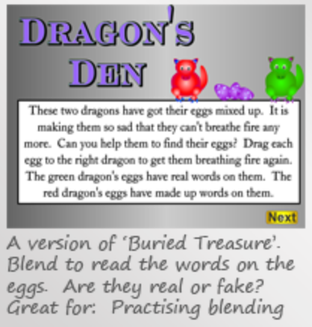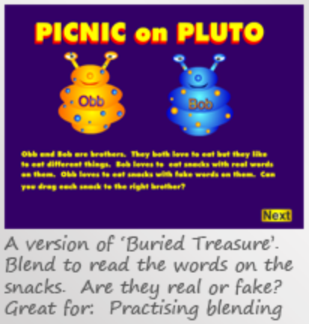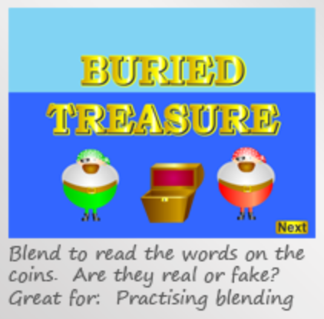<http://www.phonicsplay.co.uk/PicnicOnPluto.html>

We use reading records, which are a great way for teachers and parents to communicate about what children have read. The reading record can tell you whether your child has enjoyed a particular book and shows problems or successes he or she has had, either at home or at school.

If you have any questions, please do not hesitate to contact your child’s class teacher or myself.

Yours sincerely

Christian Hilton

**Executive Headteacher**